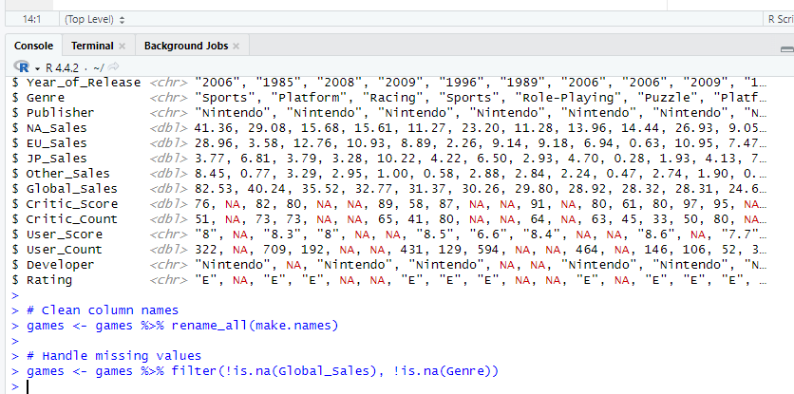

The table after the data wrangling

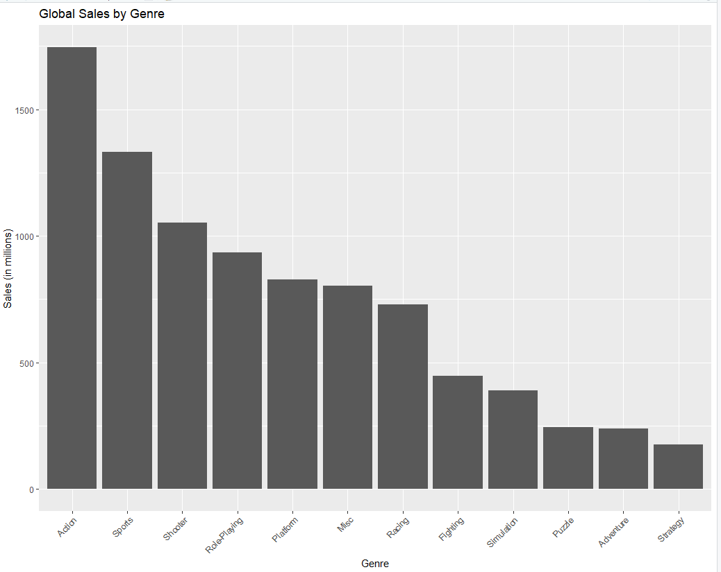

Image plotted by grouping the data by the sales made by the games in different genre.

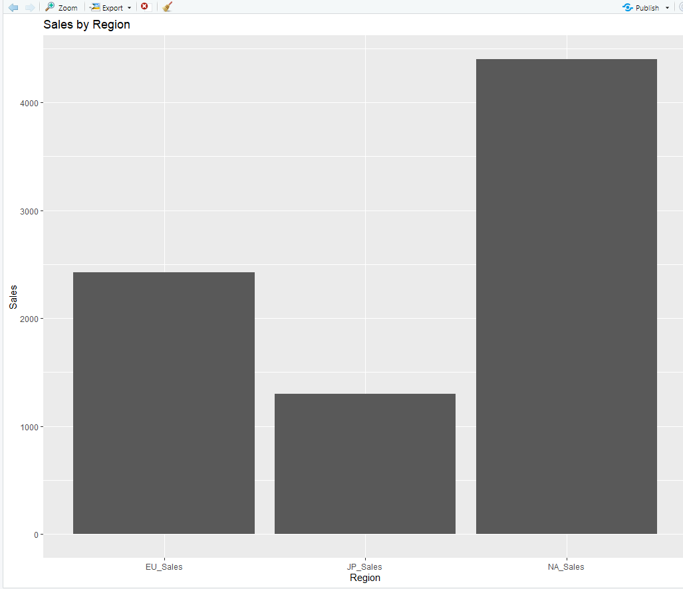

Image plotted by grouping the data by the sales made by the games in different region.

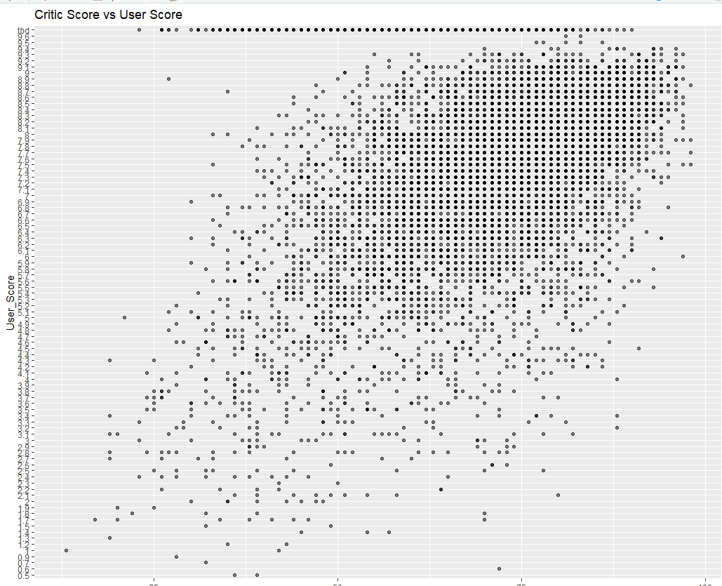

Image plotted for critic score vs user score